**K S RANGASAMY COLLEGE OF TECHNOLOGY**

**TIRUCHENGODE**



**B.E.,COMPUTER SCIENCE & ENGINEERING**

**Mini Project Report**

**TITLE : NET BANKING USING JAVA**

**By**

**K MEIYAZHAGAN**

**Acknowledgement**

The satisfaction that accompanies the successful completion of this project would be in complete without the mention of the people who made it possible, without whose constant guidance and encouragement would have made efforts go in vain. We consider myself privileged to express gratitude and respect towards all those who guided us through the completion of this project.

We convey thanks to my project guide **Asst Prof. C.Rukmani Kandhan sir** of Computer Science and Engineering Department for providing encouragement, constant support and guidance which was of a great help to complete this project successfully.

Last but not the least, we wish to thank our **parents** for financing our studies in this college as well as for constantly encouraging us to learn engineering. Their personal sacrifice in providing this opportunity to learn engineering is gratefully acknowledged.

# Abstract

Online banking system can be considered as the one of the great tool supporting many customers as well as banks and financial institutions to make may banking activities through online. Every day banks need to perform many activities related to users which needs huge infrastructure with more staff members etc. But the online banking system allows the banks to perform these activities in a simpler way without involving the employees for example consider online banking, mobile banking and ATM banking. But banking system needs to be more secure and reliable because each and every task performed is related to customer’s money. Especially authentication and validation of user access is the major task in the banking systems.

It is for an online comprehensive solution to manage internet banking. This will be accessible to all customers who have a valid user id and password. This system provides the following facilities………

* User Profile
* Balance enquiry
* Funds transfer to another account
* Complaint HelpLine

# Introduction

This section gives a scope description and overview of everything included in this Project Report. Also, the purpose for this document is described and system overview along with goal and vision are listed.

# Purpose

# Internet Banking has several advantages over traditional one which makes operating an account simple and convenient. It allows you to conduct various transactions using the bank's website and offers several advantages. Some of the advantages of internet banking are: Online account is simple to open and easy to operate.

# System Overview

**Online banking system projects** main idea is to implement a secured software application for banks considering anti phishing concepts and other security issues which cause hacking of accounts for online banks. Though they are many banks provide online banking but few of them are not secure we had seen many cases where accounts are hacked and loss of money. Here in this project we will consider all these issues as main stream issues and develop secured online banking system. This project comes will all basic features provided in regular banking sites like online transactions, balance enquiry..etc.

# Problem Statement

Write a Java program to perform NET BANKING operations.

# Requirements Specification

**Hardware Requirement for Java**

Minimum hardware requirement to download Java on your Windows operating system as follows:

* Minimum Windows 95 software
* IBM-compatible 486 system
* Hard Drive and Minimum of 8 MB memory
* A CD-ROM drive
* Mouse, keyboard and sound card, if required

**Software requirement for Java**

Nowadays, Java is supported by almost every operating systems. whether it is a Windows, Macintosh and Unix all supports the Java application development. So you can download any of the operating system on your personal computer. Here are the minimum requirement.

* Operating System
* Java SDK or JRE 1.6 or higher
* Java Servlet Container (Free Servlet Container available)
* Supported Database and library that supports the database connection with Java.

# Design

LOGIN

USER

COMPLAINT

USER ID

LOGIN

PAGE

BALANCE TRANSFER

BALANCE

ENQUIRY

# Coding

import java.awt.*;

import java.awt.event.*;

import javax.swing.*;

class NetBanking extends JFrame implements ActionListener

{

JLabel l,l1,l2,l3;

JButton b,b1,b5,b6,b7,b8,b2,b3,b4,b9,bb;

JTextField t1;

JPasswordField p1;

int a=2500000,c=0,z;

NetBanking(String s)

{

super(s);

l=new JLabel(" MK BANK OF INDIA");

l.setBounds(100,80,450,50);

add(l);

l=new JLabel("WELCOME TO NET BANKING SERVICE");

l.setBounds(70,50,450,20);

add(l);

l1=new JLabel("USER ID :");

l2=new JLabel("PASSWORD :");

b=new JButton("LOGIN");

JCheckBox c1 = new JCheckBox(" I ACCEPT ALL TERMS AND CONDITIONS", true);

c1.setBounds(50,250, 500,50);

add(c1);

t1=new JTextField();

t1.setBounds(150,150, 200,30);

p1=new JPasswordField();

p1.setBounds(150,200, 200,30);

t1.addActionListener(this);

p1.addActionListener(this);

b.addActionListener(this);

l1.setBounds(50,150,100,30);

l2.setBounds(50,200,100,30);

b.setBounds(100,300,100,30);

add(l1);

add(l2);

add(b);

add(t1);

add(p1);

b5=new JButton("USER PROFILE");

b6=new JButton("CHECK BALANCE");

b7=new JButton("TRANSFER CASH");

b8=new JButton("COMPLAINTS");

b5.setBounds(0,600,200, 40);

b6.setBounds(250,600,200, 40);

b7.setBounds(500,600,200, 40);

b8.setBounds(750,600,200, 40);

b5.addActionListener(this);

b6.addActionListener(this);

b7.addActionListener(this);

b8.addActionListener(this);

add(b5);

add(b6);

add(b7);

add(b8);

setDefaultCloseOperation(JFrame.EXIT_ON_CLOSE);

setLayout(null);

setLocation(250,100);

setVisible(true);

setSize(1000,800);

}

public void actionPerformed(ActionEvent e)

{

String s1=t1.getText();

String s2=new String(p1.getPassword());

if(e.getSource()==b)

{

String msg;

msg = "Login Successful";

JOptionPane.showMessageDialog(null, msg);

}

else if(e.getSource()==b5)

{

JFrame f=new JFrame();

JTextField t6,t7,t8,t9,t10,t11,t12,t13;

JLabel l4=new JLabel("MK BANK OF INDIA");

l4.setBounds(400,40,200, 40);

f.add(l4);

JLabel l5=new JLabel("USER PROFILE");

l5.setBounds(300,70,200, 40);

f.add(l5);

JLabel l6=new JLabel("USER NAME : ");

l6.setBounds(100,150,200, 40);

f.add(l6);

t6=new JTextField();

t6.setText("MEIYAZHAGAN KULANDAIVEL");

t6.setBounds(300,150, 200,30);

t6.setEditable(false);

f.add(t6);

JLabel l7=new JLabel("ACCOUNT NO : ");

l7.setBounds(100,200,200, 40);

f.add(l7);

t7=new JTextField("6078 5184 1274 3157");

t7.setBounds(300,200, 200,30);

t7.setEditable(false);

f.add(t7);

JLabel l8=new JLabel("ADDRESS : ");

l8.setBounds(100,250,200, 40);

f.add(l8);

t8=new JTextField("NAMAKKAL");

t8.setBounds(300,250, 200,30);

t8.setEditable(false);

f.add(t8);

JLabel l9=new JLabel("PHONE NO : ");

l9.setBounds(100,300,200, 40);

f.add(l9);

t9=new JTextField("90803 35279");

t9.setBounds(300,300, 200,30);

t9.setEditable(false);

f.add(t9);

JLabel l10=new JLabel("OPERATIONAL MODE : ");

l10.setBounds(100,350,200, 40);

f.add(l10);

t10=new JTextField("SELF");

t10.setBounds(300,350, 200,30);

t10.setEditable(false);

f.add(t10);

JLabel l11=new JLabel("DATE OF OPENING : ");

l11.setBounds(100,400,200, 40);

f.add(l11);

t11=new JTextField(" 11 FEB 2011");

t11.setBounds(300,400, 200,30);

t11.setEditable(false);

f.add(t11);

JLabel l12=new JLabel("ATM NUMBER : ");

l12.setBounds(100,450,200, 40);

f.add(l12);

t12=new JTextField("**** **** **** *852");

t12.setBounds(300,450, 200,30);

t12.setEditable(false);

f.add(t12);

JLabel l13=new JLabel("CARD VALID UPTO : ");

l13.setBounds(100,500,200, 40);

f.add(l13);

t13=new JTextField("24 - AUG - 2020");

t13.setBounds(300,500, 200,30);

t13.setEditable(false);

f.add(t13);

b1=new JButton("Ok");

b1.setBounds(250,600,100,30);

f.add(b1);

b1.addActionListener(this);

f.setSize(1000,800);

f.setLayout(null);

f.setVisible(true);

}

else if(e.getSource()==b6)

{

JFrame f=new JFrame("MK BANK OF INDIA");

JLabel l=new JLabel(" MK BANK OF INDIA");

l.setBounds(70,50,450,20);

f.add(l);

JLabel l4=new JLabel("VERIFY BALANCE");

l4.setBounds(100,80,450,50);

f.add(l4);

JLabel l18=new JLabel("CURRENT BALANCE : ");

l18.setBounds(100,250,200, 40);

f.add(l18);

JTextField t18=new JTextField("Rs ."+ a);

t18.setBounds(300,250, 200,30);

t18.setEditable(false);

f.add(t18);

b1=new JButton("Ok");

b1.setBounds(250,400,100,30);

f.add(b1);

b1.addActionListener(this);

f.add(l);

f.setSize(800,600);

f.setLayout(null);

f.setVisible(true);

}

else if(e.getSource()==b7)

{

JFrame f=new JFrame("MK BANK OF INDIA");

JLabel l=new JLabel(" MK BANK OF INDIA");

l.setBounds(70,50,450,20);

f.add(l);

JLabel l4=new JLabel("BALANCE TRANSFER");

l4.setBounds(100,80,450,50);

f.add(l4);

JLabel l18=new JLabel("CURRENT BALANCE : ");

l18.setBounds(100,150,200, 40);

f.add(l18);

JTextField t18=new JTextField("Rs. "+a);

t18.setBounds(300,150, 200,30);

t18.setEditable(false);

f.add(t18);

//t18.addActionListener(this);

JLabel l22=new JLabel("PARTNER'S ACC NO: ");

l22.setBounds(100,200,200, 40);

f.add(l22);

JTextField t55=new JTextField();

t55.setBounds(300,200, 200,30);

//t18.setEditable(false);

f.add(t55);

JLabel l24=new JLabel("AMOUNT TO TRANSFER : ");

l24.setBounds(100,250,200, 40);

f.add(l24);

JTextField t77=new JTextField();

t77.setBounds(300,250, 200,30);

t77.addActionListener(this);

f.add(t77);

JLabel l23=new JLabel("UPI PIN : ");

l23.setBounds(100,300,200, 40);

f.add(l23);

JTextField t88=new JTextField();

t88.setBounds(300,300, 200,30);

//t18.setEditable(false);

f.add(t88);

bb=new JButton("Submit");

bb.setBounds(150,400,100,30);

f.add(bb);

//bb.addActionListener(this);

b1=new JButton("Proceed");

b1.setBounds(250,400,100,30);

f.add(b1);

b1.addActionListener(this);

f.setSize(800,600);

f.setLayout(null);

f.setVisible(true);

}

else if(e.getSource()==b8)

{

JFrame f=new JFrame("MK BANK OF INDIA");

JLabel l1=new JLabel(" MK BANK OF INDIA");

l1.setBounds(70,50,450,20);

f.add(l1);

JLabel l2=new JLabel("DESCRIBE YOUR COMPLAINT HERE..");

l2.setBounds(100,80,450,50);

f.add(l2);

JTextArea area=new JTextArea(" ");

area.setBounds(70,120,500,300);

b1=new JButton("Submit");

b1.setBounds(250,450,100,30);

f.add(b1);

b1.addActionListener(this);

JLabel l22=new JLabel("CUSTOMER CARE : 95249 14630");

l22.setBounds(600,500,450,50);

f.add(l22);

JLabel l23=new JLabel("FOLLOW US @ mkbanks@hari.ac.in");

l23.setBounds(600,550,450,50);

f.add(l23);

JLabel l24=new JLabel("CONTACT US AT mknetbanking@gmail.com");

l24.setBounds(600,600,450,50);

f.add(l24);

f.add(area);

f.setSize(1000,700);

f.setLayout(null);

f.setVisible(true);

}

if(e.getSource()==b1)

{

JOptionPane.showMessageDialog(null, "OPERATION COMPLETED");

}

}

public static void main(String s[])

{

new NetBanking("MK BANK OF INDIA");

}

}

# Testing

* 1. **Test Plan**

In this application , a manually written unit test script method is used for testing function those perform unit amount of work and provides functionality.

# Test Report:

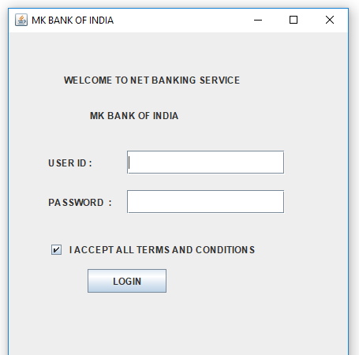 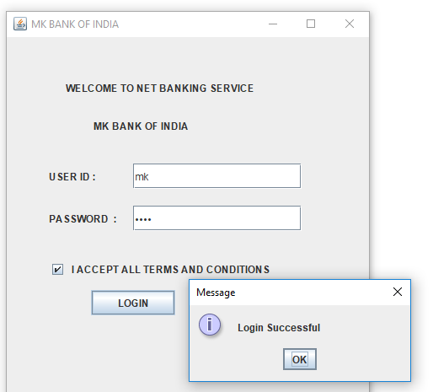

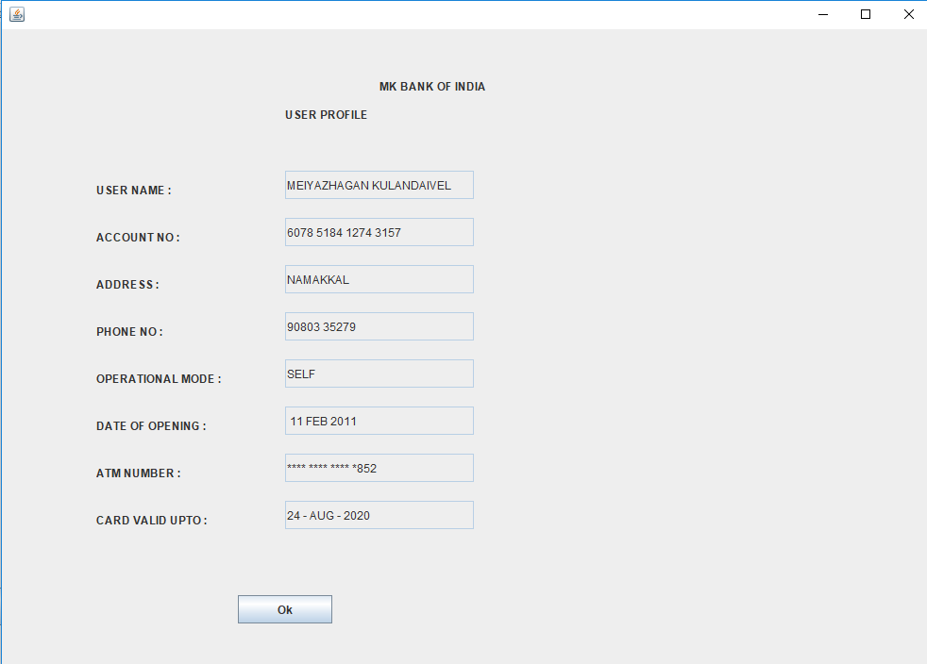 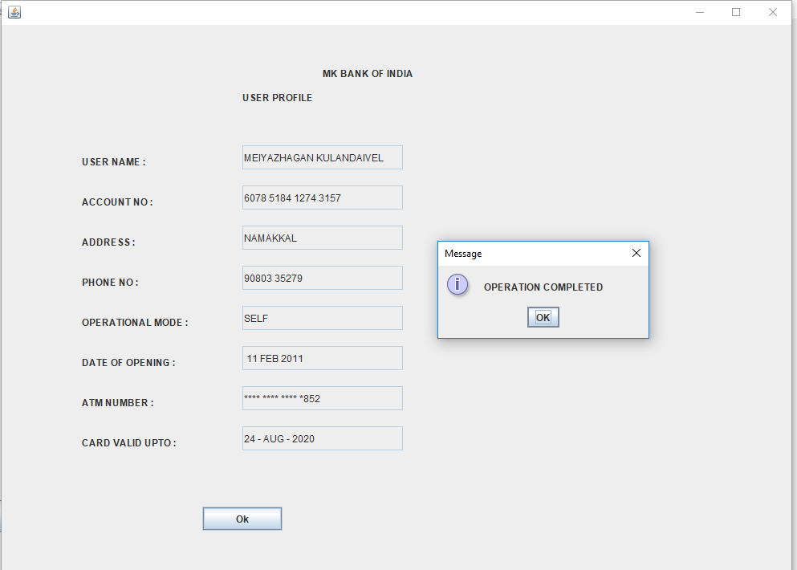

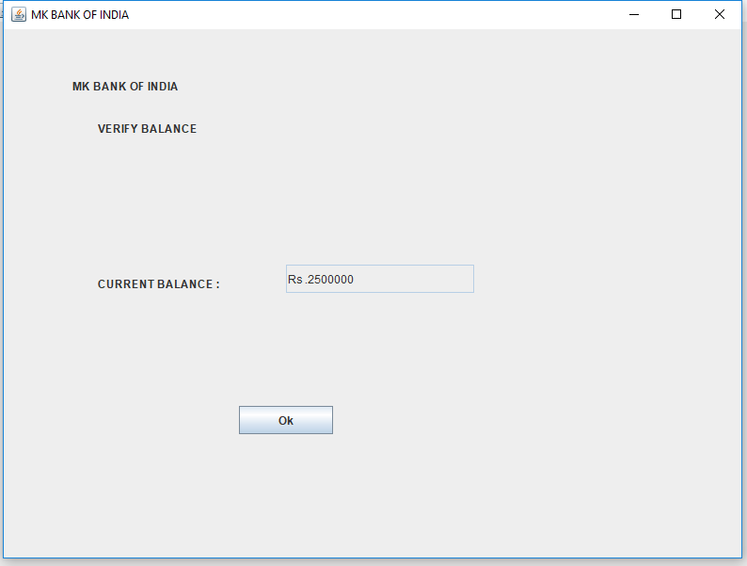 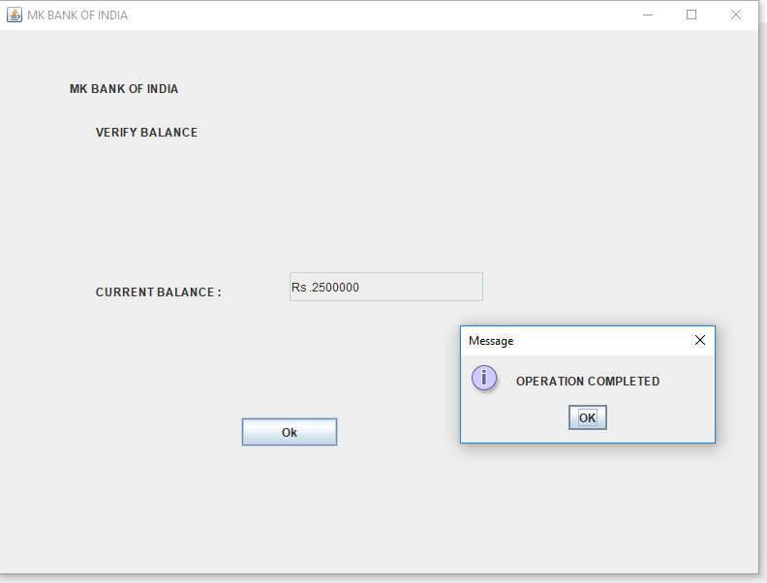

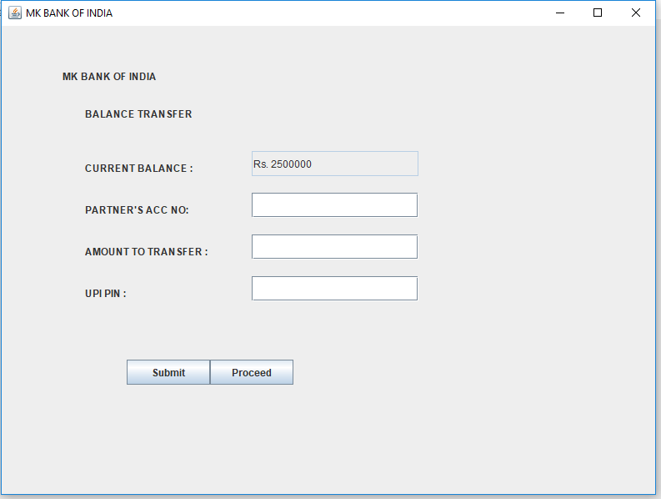 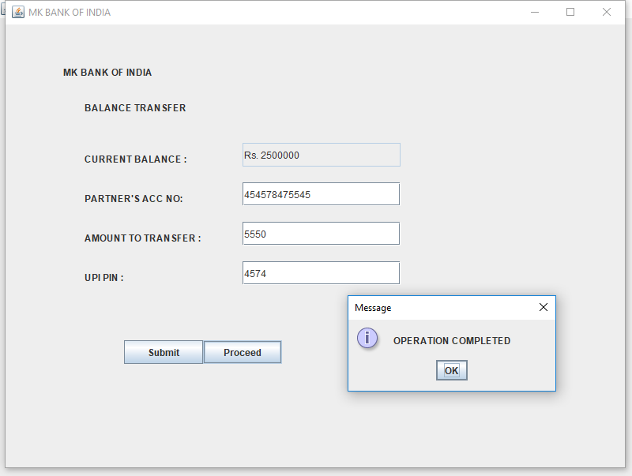

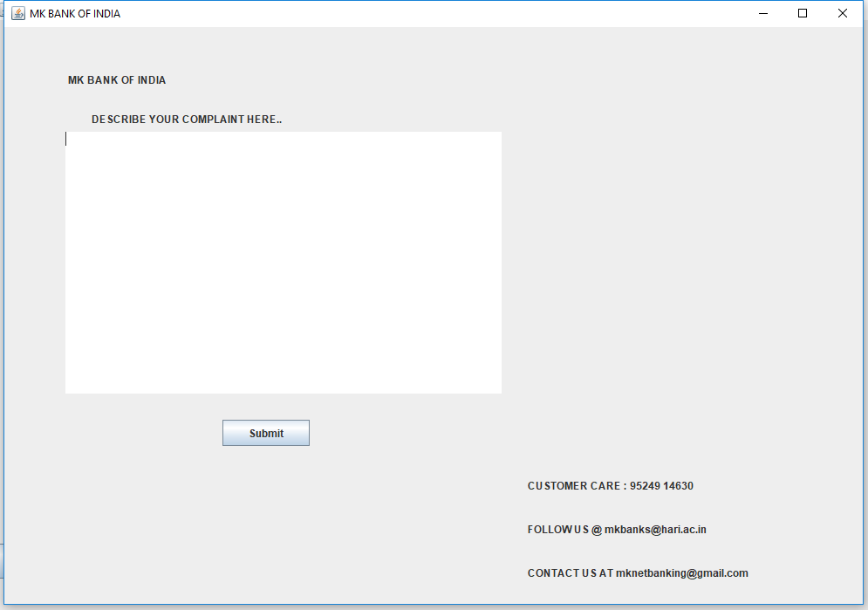 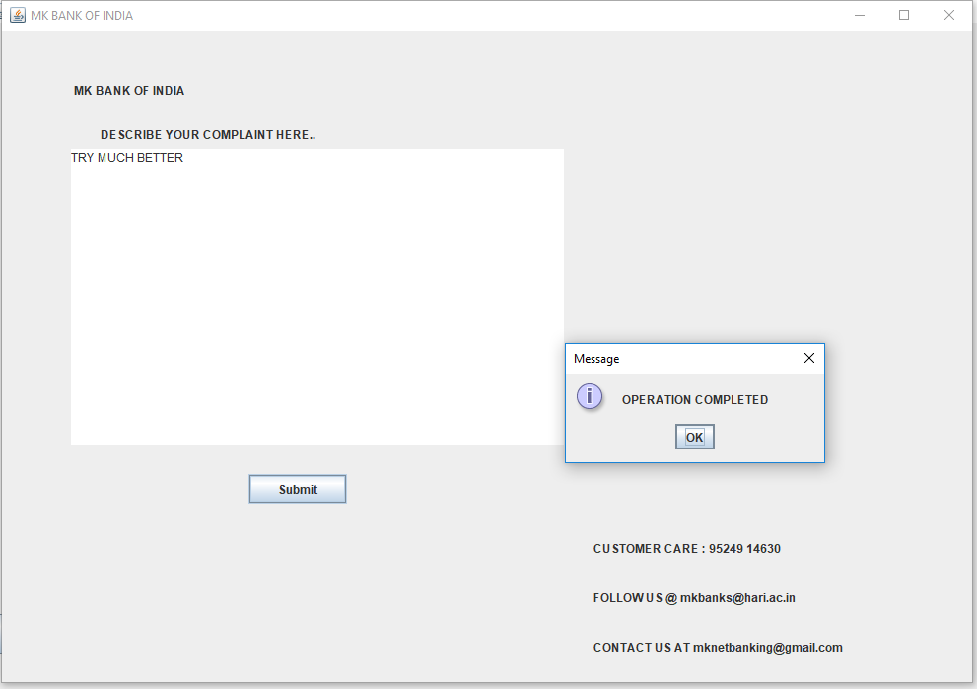

# Summary

Banking systems have been with us for as long as people have been using money. Banks and other financial institutions provide security for individuals, businesses and governments, alike. ... However, other financial institutions exist that are not restricted by such regulations. Banking System " keeps the day by day tally record as a complete banking. It can keep the information of Account type, User Profile, Balance enquiry, Funds transfer to another account and Complaint HelpLine.

# References

* <https://www.javatpoint.com/java-swing>
* <https://www.geeksforgeeks.org/creating-frames-using-swings-java/>
* <https://www.guru99.com/java-swing-gui.html>
* <https://beginnersbook.com/2015/07/java-swing-tutorial/>